**Submitted by,**

**Miss.G. Priyadarshini.BCA.,**

**Guided by,**

**Prof. Mrs. Meenatchi**

**Introduction:**

* **Online assessment is a simple project created for students to upskill their knowledge. This test contains three rounds. If you complete the first level of the test successfully, then you can attend the second level, likewise the second and third rounds. The result will be declared at the end of the test.**
* **This assessment test will be most useful for anyone who is seeking a job in the Information technology fields.**

**Software Requirements:**

* **Operating system : Windows10**
* **Tool : Visual Studio**
* **Front end : Asp.Net, C#, Html, Css**
* **Back end : Sql Server**

**SYSTEM STUDY:**

* **Proposed System:**
* **Time is more efficient and maintained in a secure manner.**
* **Each and every process is done by single clicks to store and retrieve.**
* **We can access the system anywhere and anytime.**
* **Easy to understandable.**
* **Time and execution speed of the system is high.**
* **It uses client\ server technology.**

**PROJECT DESCRIPTION:**

* **Module**

1. **Sign Up**
2. **Sign In**
3. **Admin**
4. **User**

* **If the user is new to the site, they can sign up (or) If they have an account already, they can login to the site. Then they can take the test . The test has beginner, intermediate and expert levels for three levels. The user should pass for each level then they can go to the next level.**
* **After the admin login, admin can access all users of the entire site, and admin can insert new users and also, they can delete the user.**

**DATA DICTIONARY:**

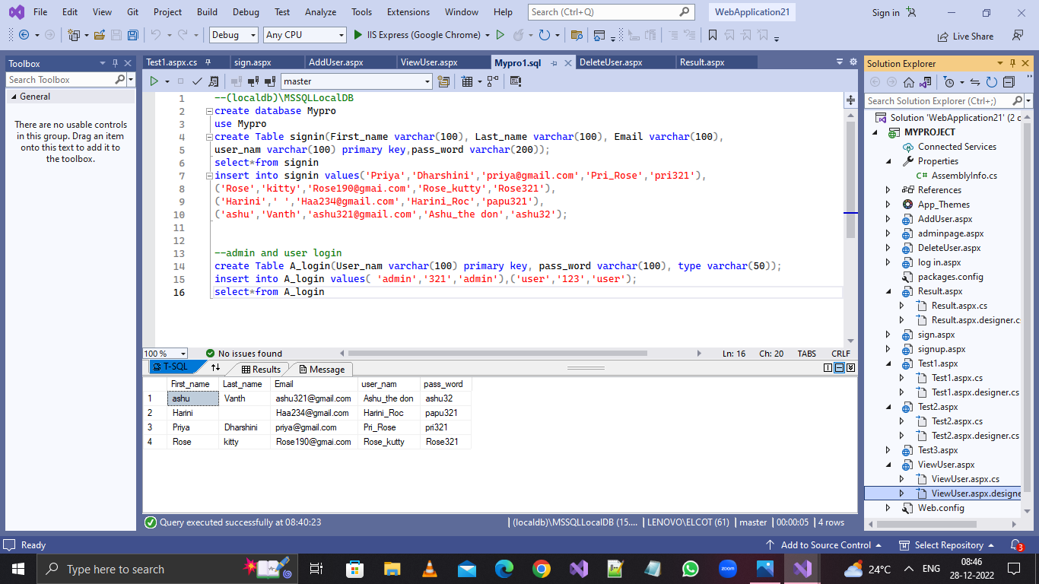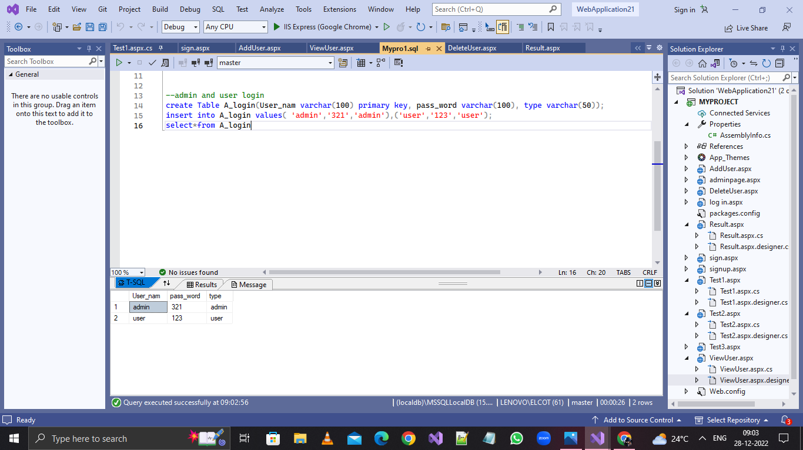

**SAMPLE CODING:**

***Sign Up***

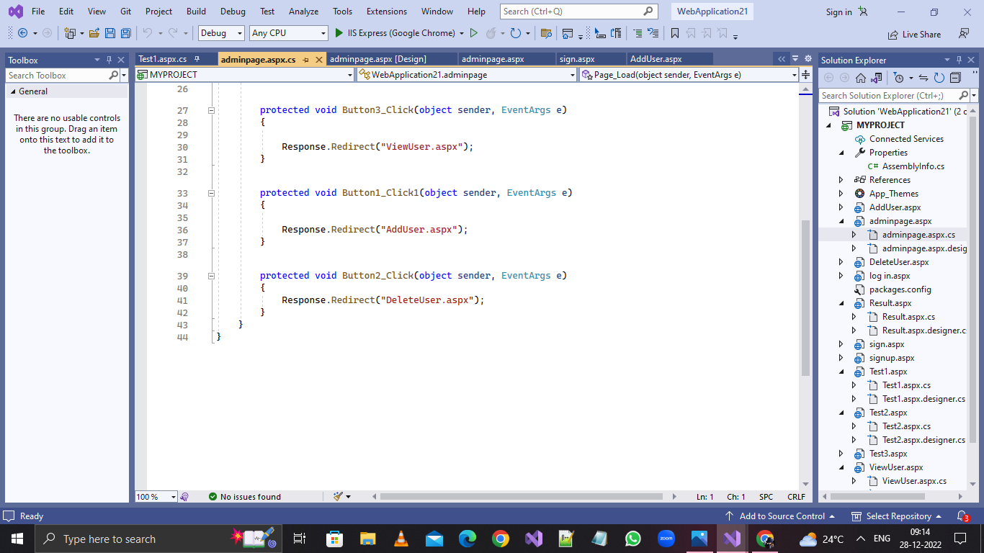

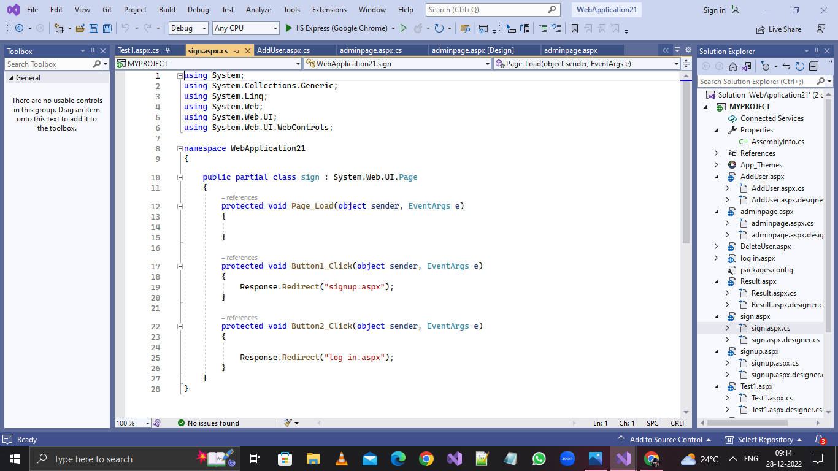

***REGISTER PAGE***

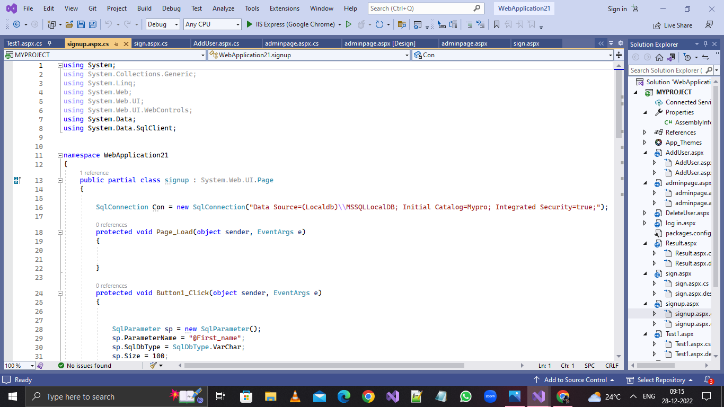

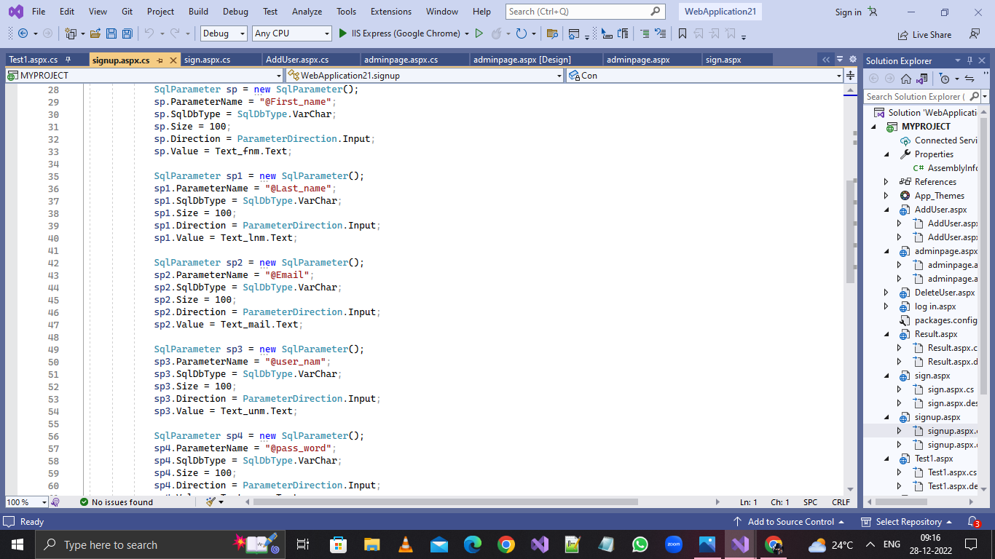

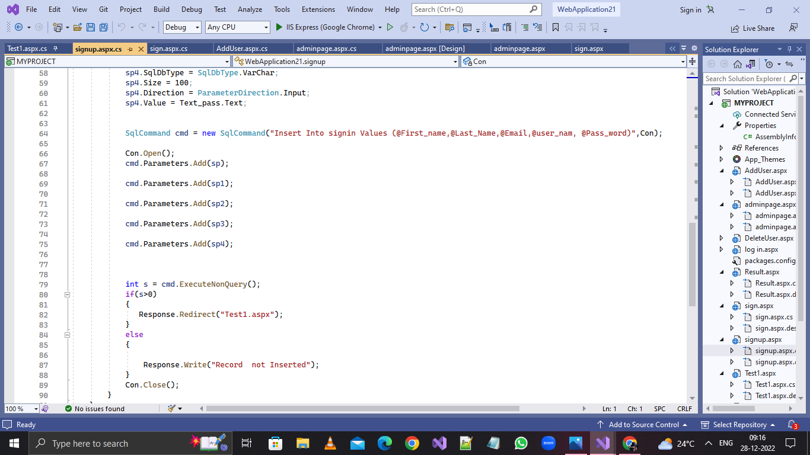

***LOGIN***

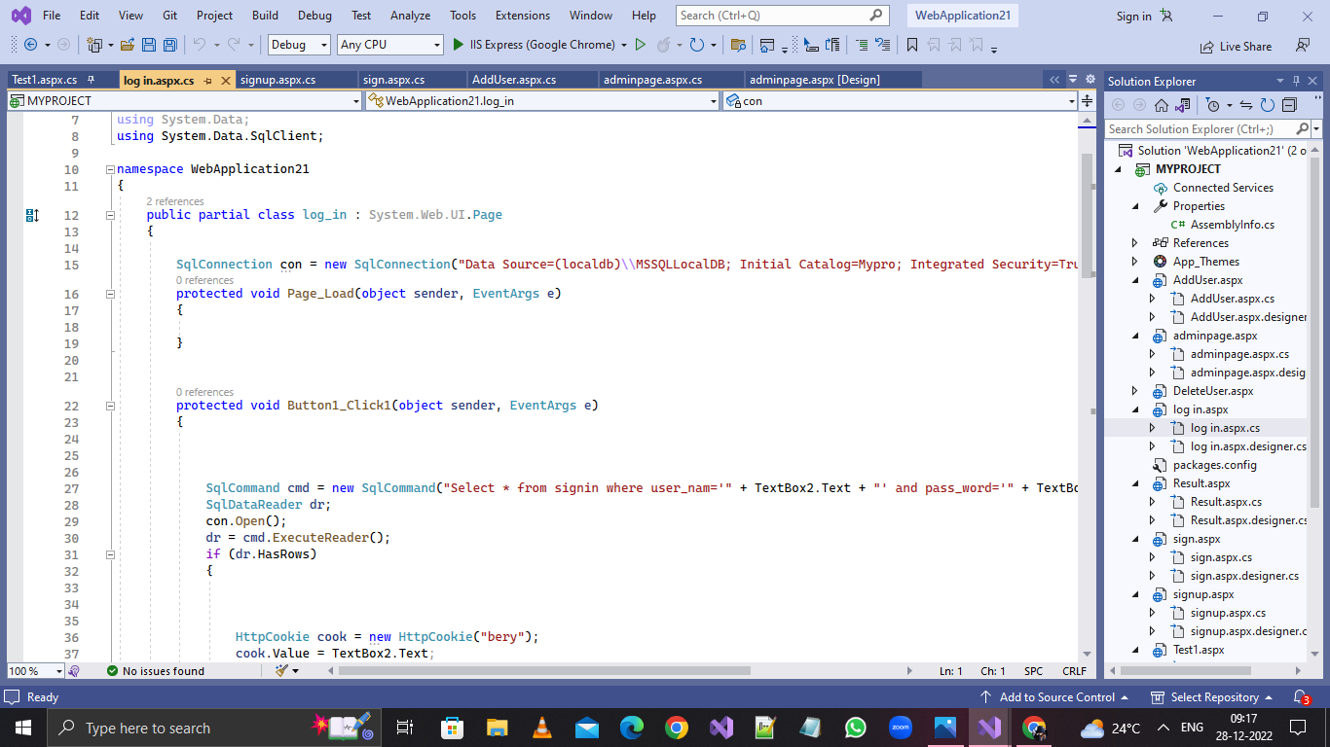

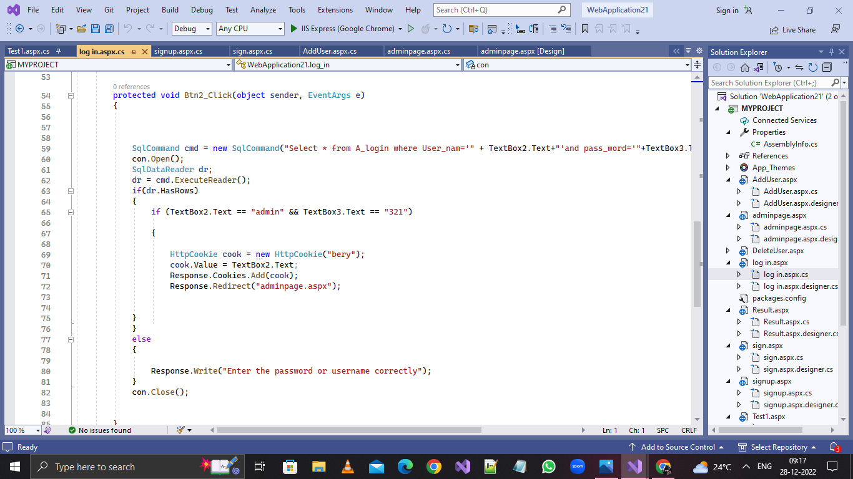

***TEST PAGE***

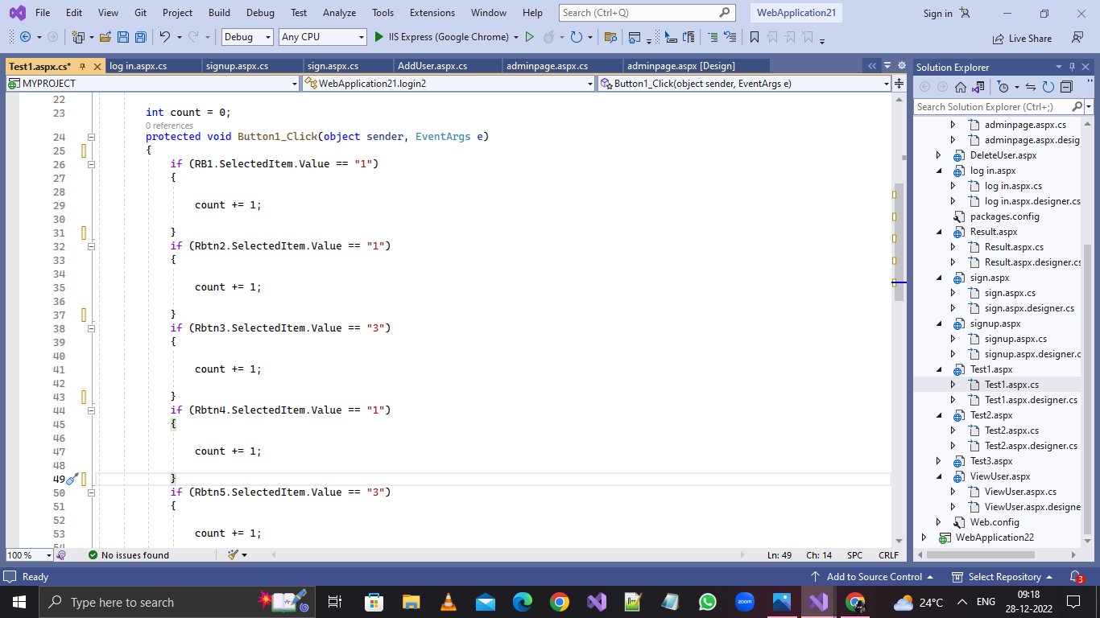

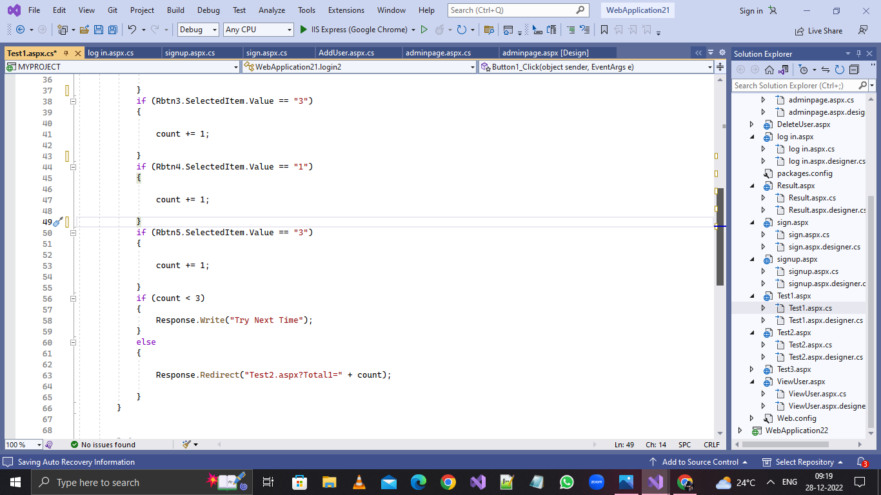

***RESULT PAGE***

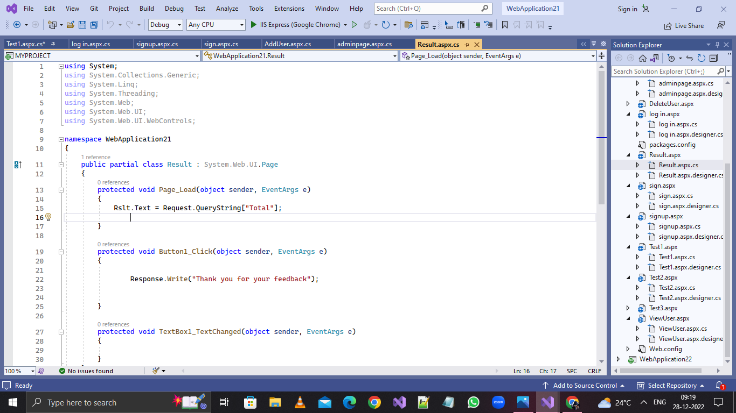

***OUTPUT PAGE***

***Front page:***

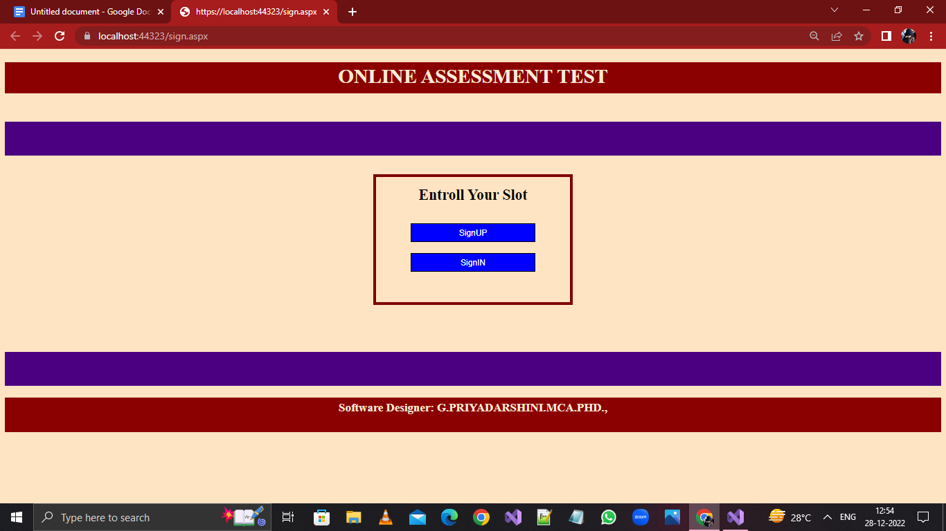

***Signup page***

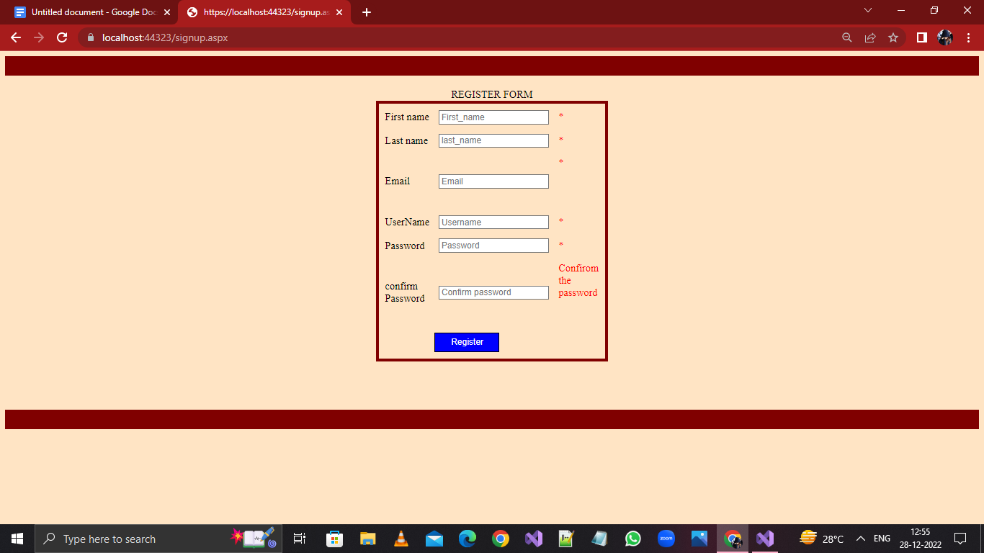

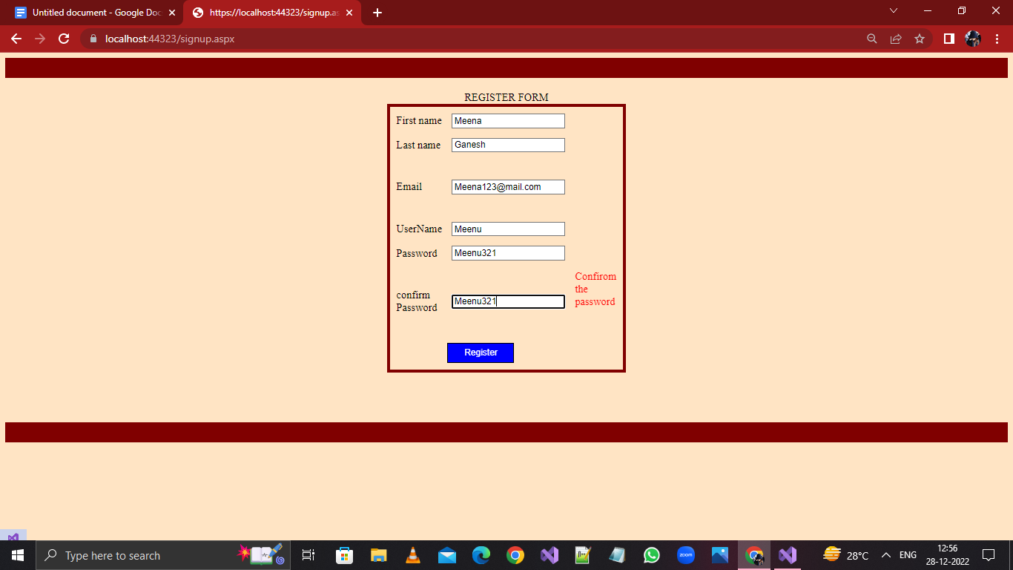

***LogIn Page:***

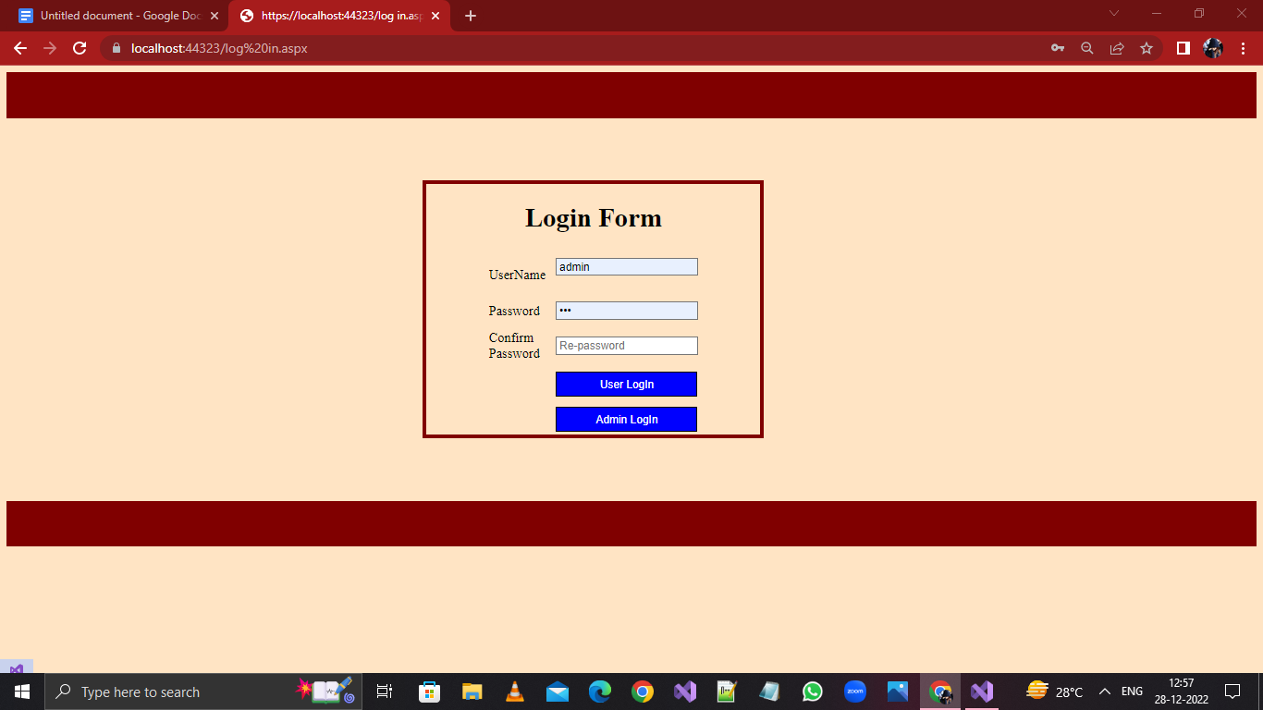

***Admin Login:***

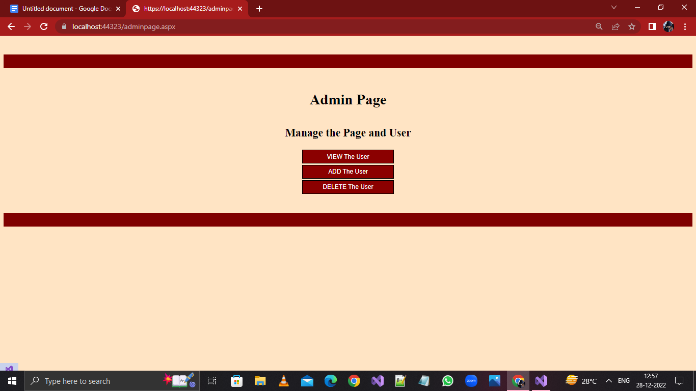

***View The User:***

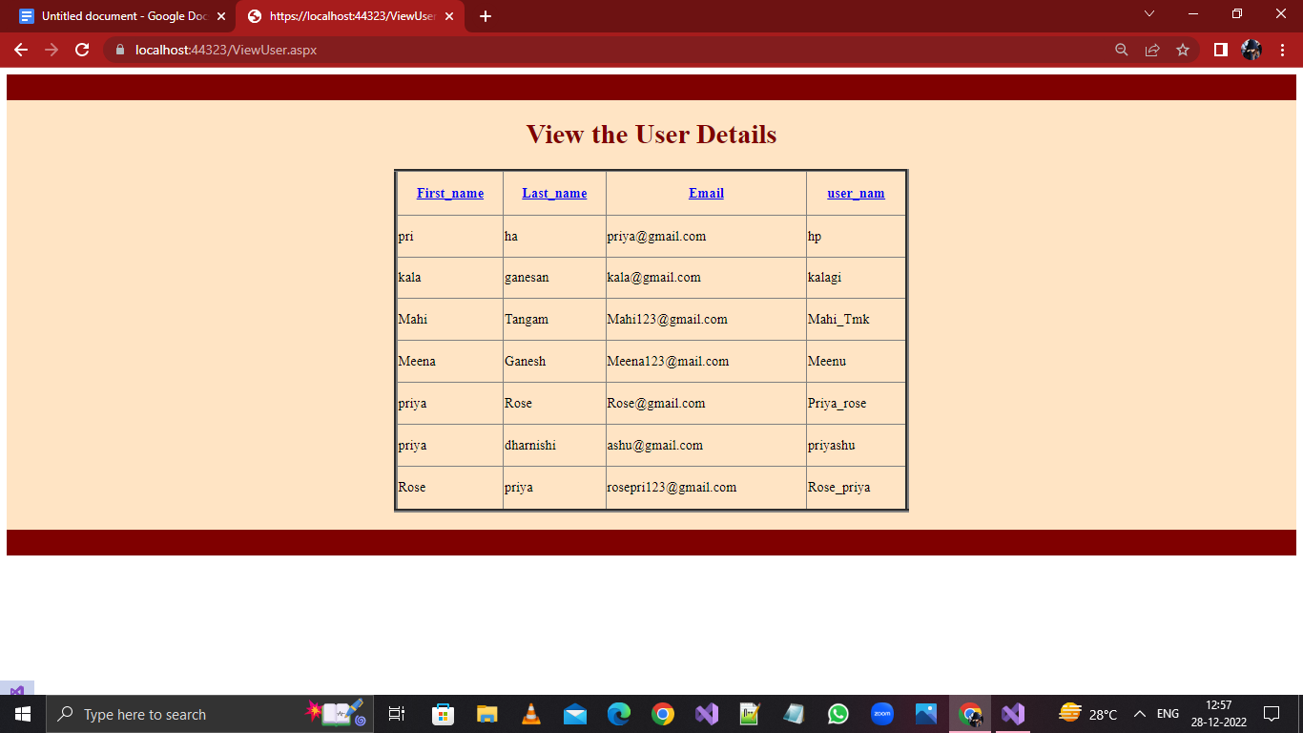

***Add New User:***

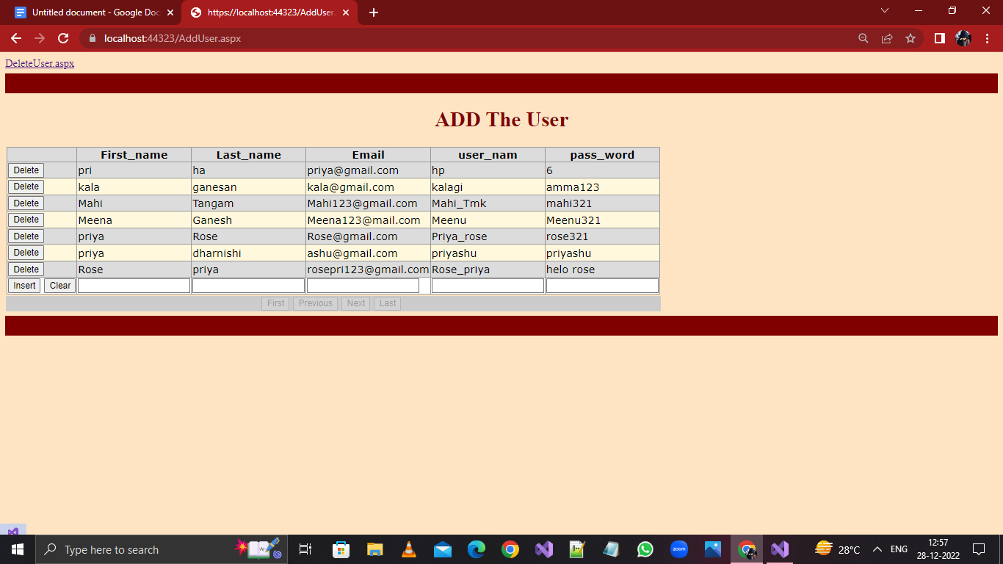

***Delete the Existing User:***

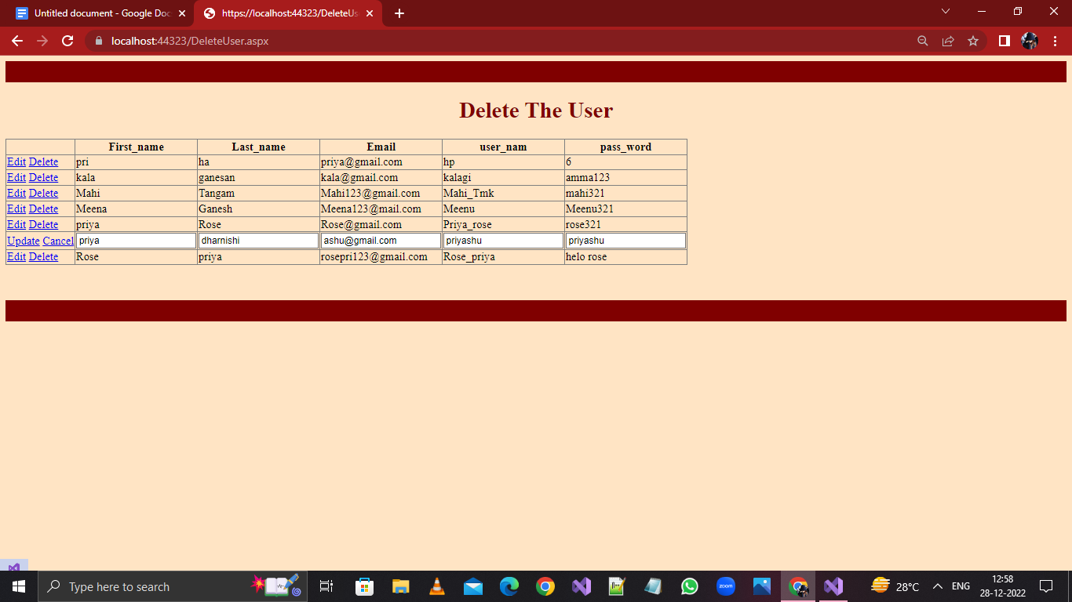

***After The User LogIn–Test Pages:***

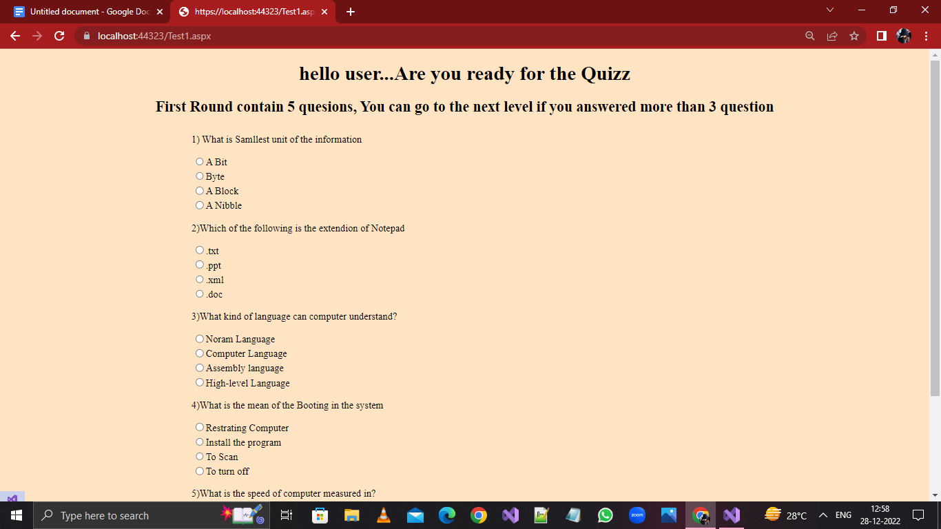

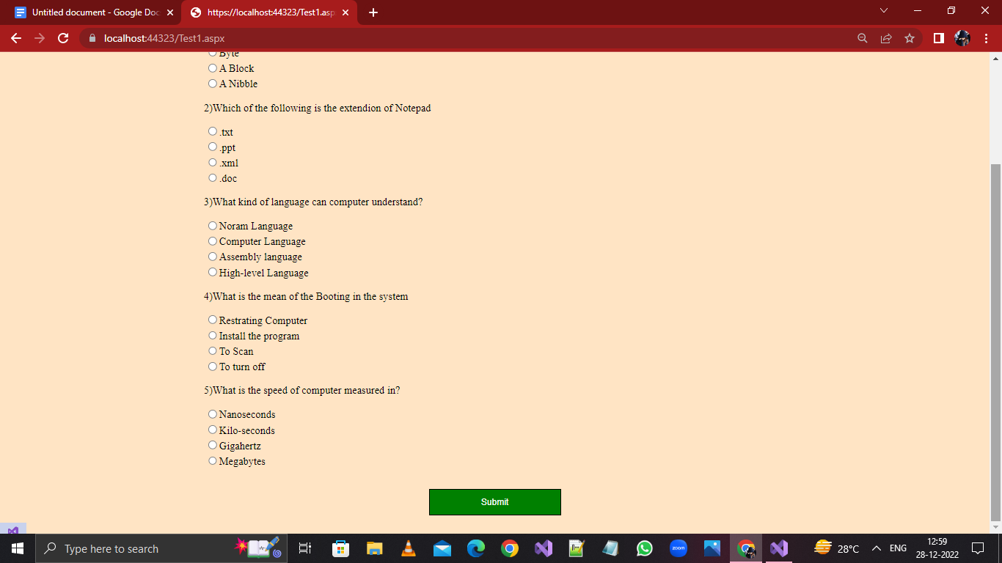

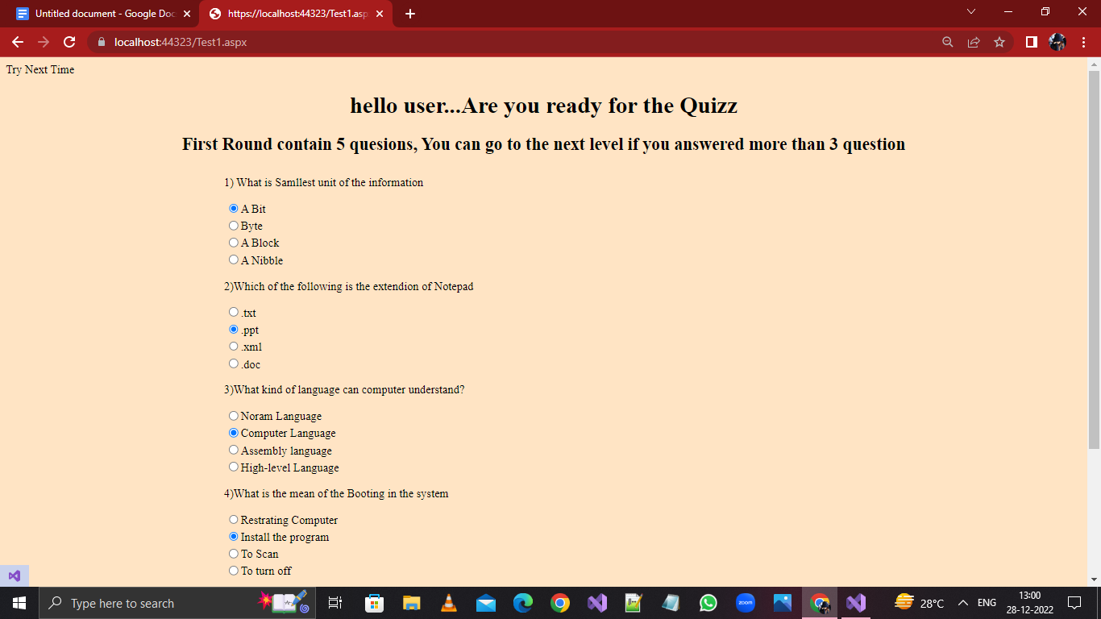

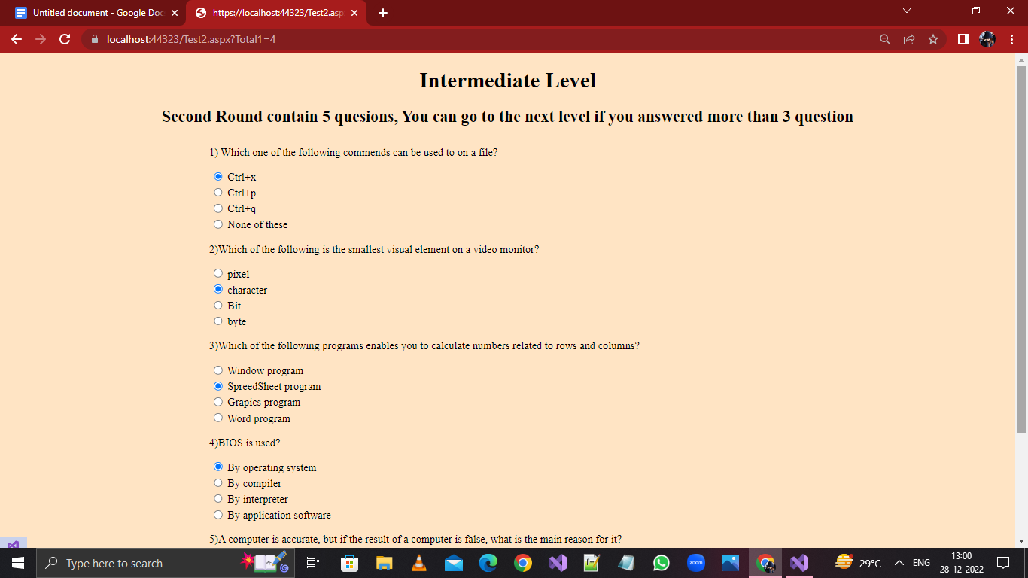

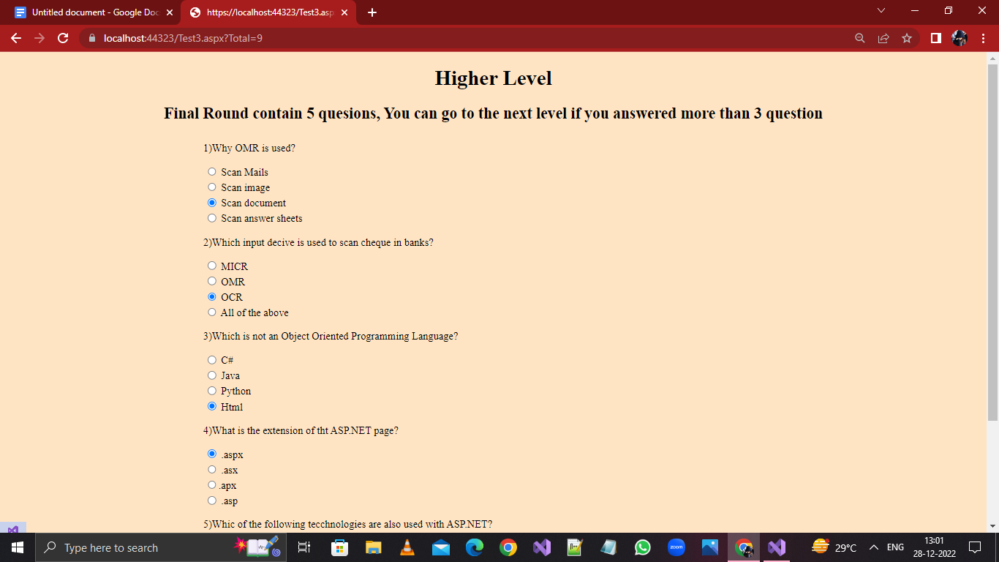

***Result Page:***

